The Creation of my VR Application.

Coming up with what the VR app will be

In the beginning I started with deciding on how to adapt the theme of the project that has been provided which was “Small World”. I was thinking of how to make a unique experience using this theme and considered many ideas such as exploring an outside area such as a forest while small, interacting with small things like mushrooms and small animals that now appear big or giant to the player or exploring a room that now feels like a whole open world map due to the player’s size. I eventually settled on the player exploring an abandoned house 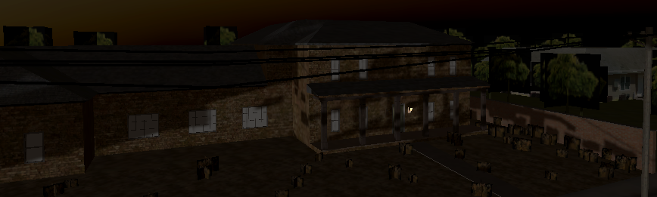in the dark, having to find gems 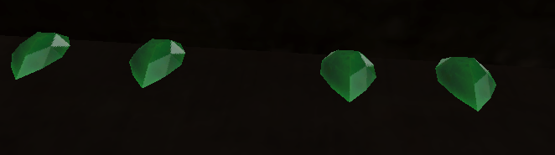to grow themselves back to their original size while avoiding dangerous spiders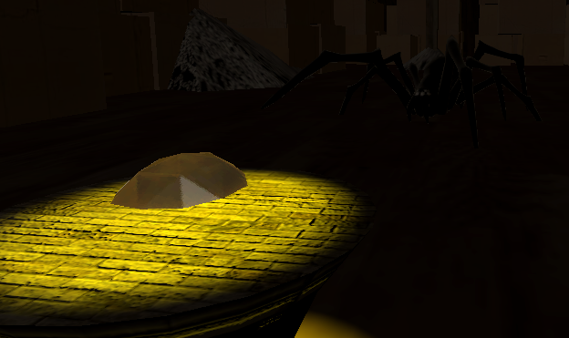 that are now quite big and will hunt the player down if they spot them.

Building the VR app

While making the game, I gathered a lot of different assets that I found on both the unity asset store and itch.io which allowed me to find models for an abandoned house, spiders, gems and the pedestals for the gems to be placed on. I worked on implementing what I learned from the labs into my game including physically interactable objects, activation events with the flashlight, sockets for the gems and fuse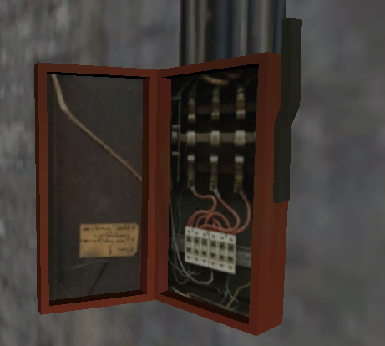, ray interactors with being able to turn on rays for your hands in order to grab an object that may have fallen in a way that is hard to grab by reaching out for it yourself, sound and haptics such as the spider sounds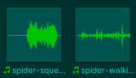 and a buzz whenever you hover and interact with a grabbable object and user interface through tip pop ups that show up around the house to guide the player so that they do not get lost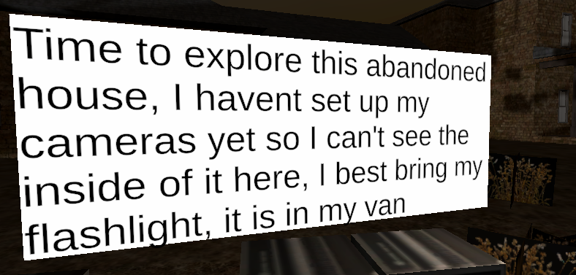. I have also implemented a basic enemy ai for the spiders so that they patrol a given path and chase the player if the player happens to find themselves in their line of sight. Most gems are in high up spaces with the player needing to find a way up to them so I made certain objects in my VR Application climbable by the player so that they can climb up to the gems which also adds to the small world setting as you’ll be climbing up a fridge, table and shelves in order to reach you objectives. Every time a new feature was implemented into my game, I would test it to see if it works and with every change, fix and new feature added, my prototype became more and more complete as the weeks went by.

Issues encountered along the way and how I fixed them.

I have encountered many technical difficulties during my time creating my VR Application from small things to much larger issues which had to be dealt with as they showed up to avoid piling up errors which would cause the stability of the app to suffer a great amount. The smaller issues that I have run into include code not functioning as it is supposed to which was fixed by making minor changes to the code until it worked, and objects not being fully compatible with the urp so their materials don't function as they are supposed to properly which was fixed by making new materials that used the same base maps as the old materials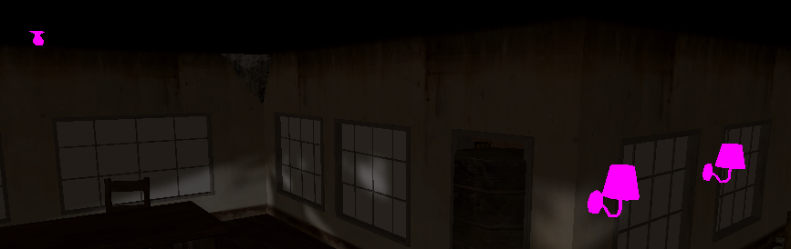. Those issues did not take a long time to fix but were still minor annoyances during the development of my app.

The Larger issues were when the climb interactors would not work, or the physics of the doors would break constantly. These issues caused me to stop adding to the application in order to fix them as they were very important components of my game and needed them to work in order for the game to be playable/beatable. The climb interactors took less time to fix as I figured out what the issue with them was that they were missing another script alongside the climb interactor script and needed to switch the distance calculation mode to collider volume and not transform position. 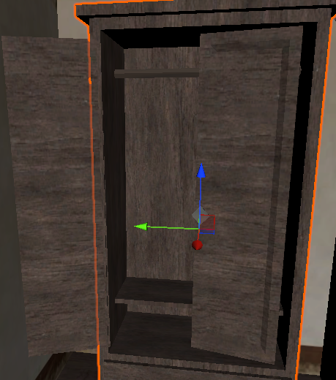The door physics took much longer to fix as I tried many different approaches to fix them with none of them working or making the doors partially functional. This issue was eventually resolved by fixing the limits on the hinge joint but then another issue arose which involved the doors becoming detached from their hinge joint and the players being able to rip them away which was fixed by changing the movement type of the doors to velocity tracking.

Overall, creating the VR app wasn’t without a few obstacles that I had to get through in order for everything to work. While working on my game I felt my understanding of VR app development grow and improve, making me feel more confident with it and I feel that if I were to make another VR app that I would not run into any of the issues that I have ran into during the period of this project. I feel that this project has made me more competent when it comes to VR App development and makes me excited to work on a VR project of my own over the holidays.

Link to github for the project:  
https://github.com/Kacper-with-a-K/VR-Things